GLOBAL WARMING?
1000:1/4B  1600: 1/2B  1890: 1B  1920: 2B  1960: 3B  1970: 4B  1990: 5B  2000: 6B  2010: 7B  2020: 8B  2050: 9B  2060: 10B  2100: 11B | IN THE 1960’S, WE WERE VERY WORRIED ABOUT THE WORLD POPULATION EXPLOSION BUT SOON PUT IT ON THE BACK BURNER & MOVED ON. NOW THE BIG WORRY IS ABOUT GLOBAL WARMING AND POPULATION EXPLOSION IS NOT EVEN ON THE STOVE. WELL DONE, HOMO SAPIENS! WE ARE THE VERY BEST AND ARE CERTAIN TO LEAVE A MIGHTY IMPRINT BEHIND. | 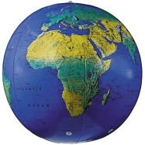 | 
IT’S THE POPULATION, STUPID!
www.jsdemba.org
20/09/20

